**The Graphical User Interface (GUI)**

We are using *GTK+* in C programming language to generate the Graphical User Interface in order to view the different data and also control different settings.

The *GTK+* is a library for creating graphical user interfaces. The library is created in C programming language. The GTK+ library is also called the GIMP toolkit. Originally, the library was created while developing the GIMP image manipulation program. Since then, the GTK+ became one of the most popular toolkits under Linux and BSD Unix. Today, most of the GUI software in the open source world is created in Qt or in GTK+. The GTK+ is an object oriented application programming interface. The object oriented system is created with the Glib object system, which is a base for the GTK+ library. The *GObject* also enables to create language bindings for various other programming languages. Language bindings exist for C++, Python, Perl, Java, C#, and other programming languages.

The GTK+ itself depends on the following libraries.

* Glib
* Pango
* ATK
* GDK
* GdkPixbuf
* Cairo

**Reasons for using *GTK+***

* *Language Bindings*

GTK+ is available in many other programming languages thanks to the language bindings available. This makes GTK+ quite an attractive toolkit for application development.

* *Interfaces*

GTK+ has a comprehensive collection of core widgets and interfaces for use in your application.

* Windows (normal window or dialog, about and assistant dialogs)
* Displays (label, image, progress bar, status bar)
* Buttons and toggles (check buttons, radio buttons, toggle buttons and link buttons)
* Numerical (horizontal or vertical scales and spin buttons) and text data entry (with or without completion)
* Multi-line text editor
* Tree, list and icon grid viewer (with customizable renderers and model/view separation)
* Combo box (with or without an entry)
* Menus (with images, radio buttons and check items)
* Toolbars (with radio buttons, toggle buttons and menu buttons)
* GtkBuilder (creates your user interface from XML)
* Selectors (color selection, file chooser, font selection)
* Layouts (tabulated widget, table widget, expander widget, frames, separators and more)
* Status icon (notification area on Linux, tray icon on Windows)
* Printing widgets
* Recently used documents (menu, dialog and manager)

**Examples of GUIs created using GTK+**

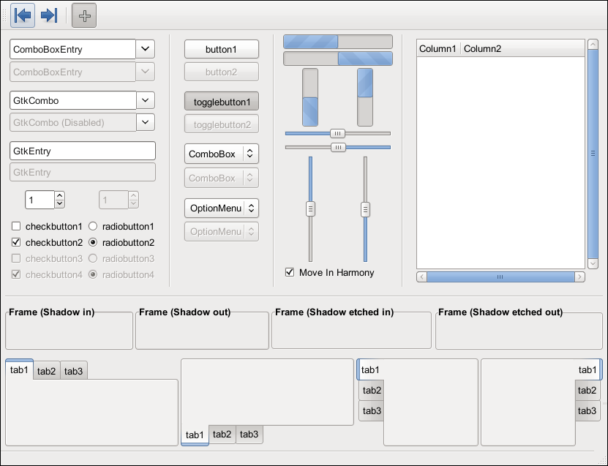

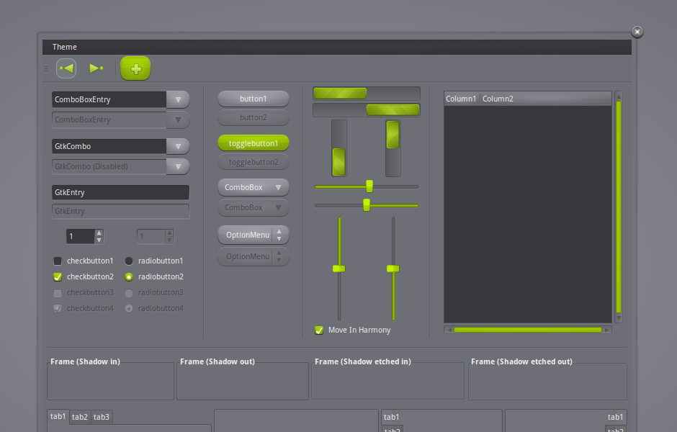

**Proposed Layout**

